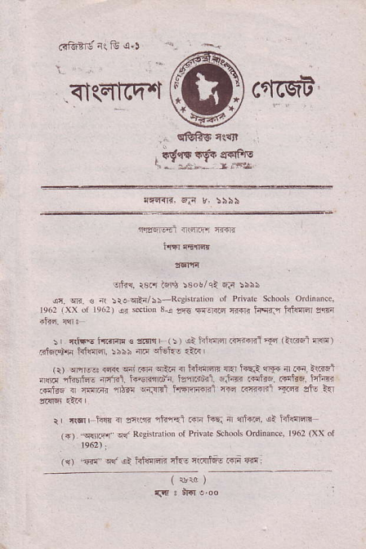
<I(qtcq'"i cqrcq? ,sTyrtr ^{sms 4..qr}
^{Ertrq.} r8s Fr., :80!/qi 6F :555
ors4!{rreqtn/::,Rc
^{e62} _{lxx} ot re6l) jr ^{sriotr s,j} !h- nqG riilr hqr.n irF@r1rrl;]
: {t* _{ta.riF 3 fli} (!) !a _{liJdidi.€{n1-q} (IiF€-r fl@) E@ri hfffii :s:i _{4F} ^{!H:-} ri<
_{rrr} ^{qmE:} ra< _{wim} lrtr _{{ hll:m} ^{qn} _{t+E} ^{qr5.} { F. iF1 nffi nhn< nilrt. _{f{nttui tnr"rnrl.} !J4{. FdF. Fil@. fci.n F1tu: { _{ffi6r} ^{'rt"!} _{u-atrll liFrqmii lt r{{cFl} ^{'sni !t} l?1
_{r} {qr hnr i r.3 rhr_ti .qi hE 4 {fr@ at iilffi _{{{)} ^{_.rI]@} !t' R*i(riidn ot Privac Schools Ordimnc. ^{le6l} fxx or
₍₁₎ ^{-Fir'} !"f il ffiflaB 4J= 'tri'F .i,_'r {{:
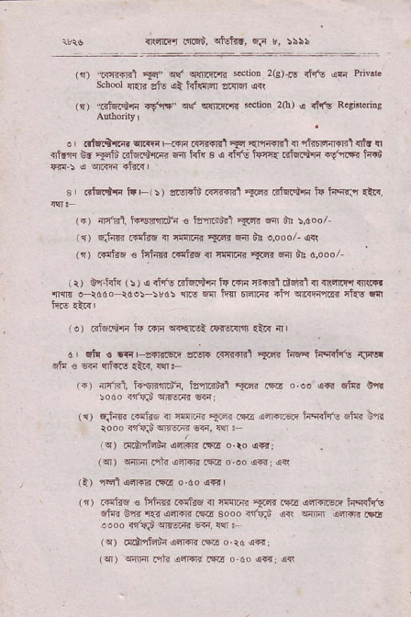
_{{\am"r .rr.s$.} ^{qtutrr,} FF r, s:5\
_{lr)} ^{mRil} _{Ts} q{ q{rrfirrR ^{s€tio. 2lg)-rd} _{dfs} qti Pdvit ^{sch6l} {{li _{!tu} el _{idl'r4 ffi} qrl
(q) _{ctui€F +d'f''} ql q{rrsi{i sctjon 2(h) ^{q} dirr Rqr".rig
_{o dfatffi} ^{qrm,ffi Rnwrl} _{E4} ^{'rmo.l{} f{rF1im?l{lfn $ ^{.f6ln E} _{"FJi} nftrd,{i-r fl hi{ B 6 itint h:n{ RI4S,F.{r{r tu
s .,t*!it" FFr:) ar.r+id ^{F.{?t} _{{!n} RLE+rn J+ iF{J {t!.
(+) ^{4Frrit. irEond'n { irtrdrl} _{1cr<} ^{{4J} "'!, ^{:dool 11) djin Frtds { rnlr{.} _{Srr} 6nr tu qooo/' {<!
^{'r} _{. @re € it'4 .4e {} ^{'FFTGR} _{*F.} ^{q} lii 6,000
ir) on.f<f{ ^{(:} ₎ ( rnis rifu.df tq &lr {i.n't rM T .n ftr'r r(d ^{rn4B} r*ao tder _{:!d5 1ro w fum Ffiqr 4ln} ^{qr.f{} riri ciIs cq
i€) _{di6dn tu m} ^{qi{iFl} .qil.im {tR 4,
6 .fc € rr"F!+REri a.srF r.l3r{ril s'B hF i4qqitu ^{dr:rF} qtu€@q'i@.t6.q.
(.) {rnlrl, tq€rnnEu>n, tdaFnr] yB m _{o !s €{} ^{qlrr} olm _{$M {is} ^{qrFlR} @l
(1) _{eit{nr .FtaE T} ^{'FF@} _{Fi{} .{j r'ftEe liqih<. atT. 0'R rooo _{{raiu>} !lF64 @, v ;
rs) _{.idFitnia} ^{qsrrR} cra o.ro a*l
^{(q) .Fm} nlr oirqnm o ooo€:{*
^{(a)} _{Gsr} ^{q.i+F.*ir} o _{do} qfdl
(r) ^{,ir{tq € iitsR .:mirq { rc{Fr} _{am} .s6 a4rqrstr h5+tu ^{qirr} Gnr.rdffi.tr sooo.t'irj s4 @r inm.rB _{,ooo {lrqI} ^{qrTEa4} @ {{ :
^{(q)} ddrnr4ni 3ffi M ^{o.} rd a€;
(q) wr{\ oli a4qr ,!F o ao {4, !d
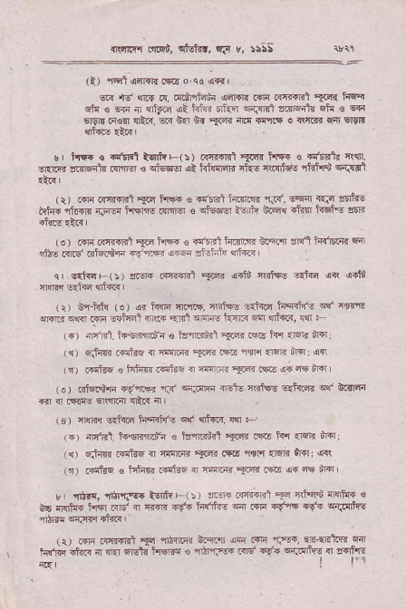
{rrrY'l nqi, ct-riN. fn '. !:ss
(l)'F1a4F,r.Eoqds€'
e.! {d sr6 F, ^{d.tnian{ adr€E @ e1?{.'t} _{*ir} liq? .iq € €Tr r] _{dFc ai ife tiqn} ^{q'liirl} _{anrqarc} ^{qrq} € q{{ ^{qgrn.{€{} {ER. @ ^{6{ dr} _{ar-€} m _{r'1!$} ^{q} 4@ f{t sl91! ^{qrl@} €,.
s I hT. ! ^{a,llrl} trntrE(!) _{c{q{fsi} ^{5{r.n} tsR € €dnatu ctlrrI, oqrFr clffiii{ _{dN €} ^{qiE@ qt} hftndR rhE 4.{rlqq 1trn$ cr.rsl
_{t} .# _{ffifdrs} ^{lac} _{F\. a} qn! ^{iiirm} r F. E6 sF 5tt€ _{Fi&} ^{-lt@} .i-- _{ls} ^{(fl6} . _{,lbd l .} ^{e} _{iFr E {a} ^{..Ene} dtF
^{( e} ₎ ^{.{i Rnr{'rit} _{?ii} ftlF€ ! _{rn'FE1 h4ffrq} ^{gFi.t} a{t i{nmnt F, ntrE .rr.g'El.adF .s-qF4 an.n 3f.:itu d@
^{qr} E{i{qF(:) alq{ ^{@mil} _{-R} d+li cGl{E 6ai@ d4 @Jt _{{ffi} ^{q.fTd qri{6} r
_{{:) Bq Ff!} ^{(e)} a. h@ rl.iis. _{ctit+s trnifr ire?ii's} ^{qtr} 4€rt @nr n€ m FlYdt nt!4 <rd sitE kiF _{sa'} ^{qlff,} ilr F _{t.)} dni4l. i+"qnnr.ir € ^{id'tr6"'rt} _{1@} ci6 tn 1F{ drq rr) r;tm r:iF5 ^{{ ffi} {tfr
_{r{)} diJ6 3 ffie{.€i@ { ^{ffic} _{Td.!E} ^{q.4F} trd (o) 6i6|+F _{{{tF4 r.n} ^{q.itF} 4.rE tRlq6 e.&?4r elr sisFn ^{q} _{4 mt} ^{q$rdl} {ftr {'
(s) ^{rmi} 6.tu4 tnqilrE otr {fa< {:
(.) 4n'Rl t+€r+idn ^{€ ta"ftiid} _{E:n} .Fd rd _{rrqR} d6: ({) _{6iii{r Fltf6 n ai@} ^{'<R.s@} rtlt ar6ir trsliq* rt) .@trq e _{tsfis trt€ {} ^{'nn@'fF..*E} s{ft mq
r _{{tF.} ^{'m'fi6.lq]li'| (r) cr.{eil} _{F} *Fd"!'fl$ts € t6 ffiiilT hn 4d { _{ffi r* ii!'rft} ^{qil ffi} _{"g'is} FtF {trFfit ,n5rn diFn ri"R
\, ' @ ^{(fiF+rf,} _{F fJ]@ n'r} .h 6e ₁₋ tn w16' @ h@ *r(. i _{e} ^{5ficffi -} _{"_tr--z.4!} 6!i. F:rtro.9s1f
_{I} r'r
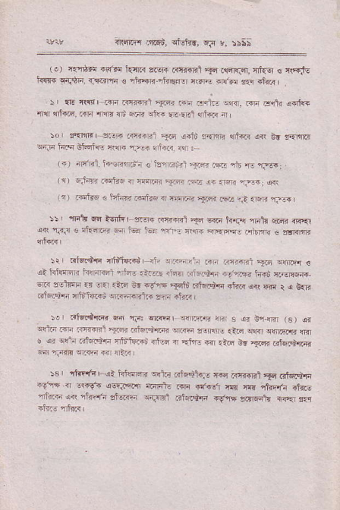
flcr.fl _{llnFd,} ^{qtr{[.} rJ r, isss
_{1!)} ir4tdr ^{+nfin} hT.r ^{azgrr .{f.srrl} _{F} rldr{lqr, nf{6! € 't'{JE _{h!:rF} ^{q{g4} {]nnln € rtu'+Br 1hFi.r ntF @!tr sql .tRr
^{!, lrn rrtrr-.+rq Rni€El} _{Fdn} rfli Ed.. 5@. m Fqr4 s{l{+ _{{q} ^{qt@,} R.d {'{n _{{d ffi} J(r _{'?r.e.t} ^{qtr.c} 4
!' s<FlB ^{zm.mfRi} _{Trd} ^{!+it} lEriB 4i@ dn 6. !r,.m _{cr;ii} ^{ji.q} EndF _{{@ 1-!i} q,i?4 ^{q{} ; -
^{(r) {ln'rltrqnr;i} ! tcrrtrft11F r"r. _{ntd} ^{.r-} {F.i ^{(a) rJ-€ F ttr6 { 4Fm} _{nar riE} ^{j+.@ 4Fn} _{i} qri rn) rrtr6 < irhr .+ ^{ri ffi} _{arR} ^{m} _{";l} {FE nrj+
::, lTit 6 _{lgtnr} ^{j} srsr€ _{Rr-rri} ^{=F 6@} hr$ {rt .@.I{'{, ,* nfi! € ^{rl-dFr} _{F4} tqn ^{t-q srr'. rw EFrc} if6 ! r € smr
:i 3isBisi _{fltiffi Ii-} ^{qr,.-ii:i} _{rF Fq.1} ^{,r,, qq..n} € oi hi@rr he{.fl ^{al-t} rir@ _{ii{} ^{,rt5} CF ^{-€'F} _{iaqu} :l:w m rslmi r! En.t6 ed ^{rl.'r} _{Fti} ^{Ftz+F} +tfi3 ^{dir} +d _{r} ^{q} &n iaias{{ {dilll: ,' ^{q@;FrtR} sfli }iiR I
\er ^{46ftirrrir} w nF e. !+@ (s) di eqli ^{m lll1@1} _{3F?} ejen.incn ^{!'r@:-rc} .td _{sqr} ^{q{em} m _{u} ^{q q!-6} cH,F atituFd ^{{rt@ i} iir @ ^{.iF Sr} _{saF} trffiqFr ^{q} {qs w.q {rr {a<
!F, ilirrA{r {l _{t} jIEm ^{qdir Rtuth} _{"r4 iT{rrlBt} ^{!.tc} dtFidllr --fn.. _{crt'F} ^{qqF.fJ} {irr+. r{lr ir..6.r rq{ ni ^{itrFln itG ,ftr@ {il} _{"lr'-]1r ztu@} ^{qqrFr} _{r?iq err} ^{qaqF} laF,tu rRq fir
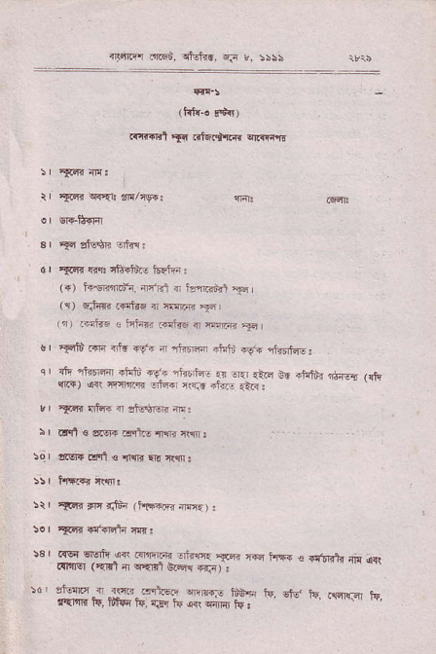
r&ror net, rlEJ6, +i !, s:ss
_{tr,r1r.r.l} ^{itn} _{..te+r.{r} qrri"r
tr _{?cr{} ^{q{Et} dnlcEst
_{d} ^{'s{} !?r rit tnre 15Ffii:
1.) i+qfi.tr1 rir'El { lerREi 'F
⁽¹⁾ F,F r .{'tuq _{ir r:]m} 'gr
^{(r)} rir6 ! lnhrr F$Tq { ^{irx@} F,
o fFri i"'r at{ .9e' r lkffi .tuti +t" rhntro: q I rir nbffFr ^{rtuiu' rf+} _{"nrbrfrF} {! .r1r {iEJ 6d ^{.tuSi} d{!E (ft _{qr")} ^{qqi rr4rlln .'ier Nr{- +i<E} .iR : ,, ^{'{.qr} i't r d ds*!n ft!
: I tlln s ^{er{ drlc} n{r ftfir:
50r ,nBr _{ian ts} ^{qI{R} rlr n|s.
^{:tr} Al'rt tn trifi (frtreF-d ^{nF4.)} :
^{5. I} _{TFri} lri.dl4 n{ :
5€ | ^{Rq 6E r} _{-i4 Fr,!@} ^{.l;l@} 3@. @ rF+ ⁻ {,rDrrt 4' ^{o{} _{aFlr6l} ^{(qn} _{ir} ^{wnl} wFr4 T{F) : :d ^{t'.iF.:.{m} Fq'€i, e@,r.dt4 ^{rd} otr ^{5'.} _{aldir.a} ^{\r} tqFur lq, fiF IF, rJ.r Jt ori {fifi tn,
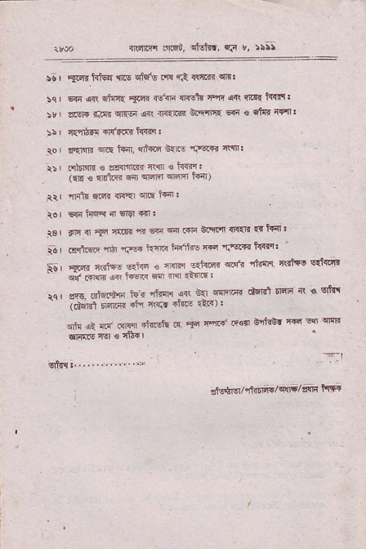
{]lrflfl _{.trqi,} ^{qtot{t,} .i t, 5rat
:a ^{I} xF{.hl6F $.s c&'E Fts si: rrnB? cn:
!q | 5{4 dn _{6iqc{} ^{,aFr} it'{i si{llr n rt o{\ rtfr _{f{iq} : _{5'} ^{I} a.ElF _{{tci} ^{qft:i} dn 4q{.dt _{e'flF{} ^{qa} € rfi' i:Ffi: _{!5} | nrYa.r .r{t.rr t{srq :
ro aqmr _{wE tfii,} ^{qi*q 0{.s} _{"r}qr,} tlw:
i:r .{tdtR s sfirftrr fi{ € hlry:
{EE _{€ EELt{} qil qrqikr ^{q@f,} r€I)
_{itr} rnft s.nR _{nrE]} ^{q|E} isr
_{tor} ^{g{r} rd6{ n Ern sl:
rs ^{i} _{fE} { _{?q} i@ 4 @ F r{1r GFF @tE E tq: i _{| .s.nM} ^{'nir} rF+ iqna h'rtus ffi'c'!i<s t€rr: 5s r ffi{ c.itr _{sF t 4@ nam} ^{qdf. ''l_T} 'lq fir5! sft{llB
⁻ _{+ iow} !q' t+srG w ^{n} "F6:
_{rcr !f6..r,Ers-a} 1E. _{r1$. ic} ^{q} 6rFF dEr.t _{td6} 4 € crht ⁻ (rtali _{6ar.{.} 'ti i€n +hi? 'a'r):
^{qic} dl ff' _{m{} +t ..tu _{a} ^{'iq} _{r4{ tqq} ffi! _{nd ss} q{F
'.-l
6fr.lr,....,.,,.-.-
_{ltlS$r/lhfrlrvqlrt/sqR} 11*
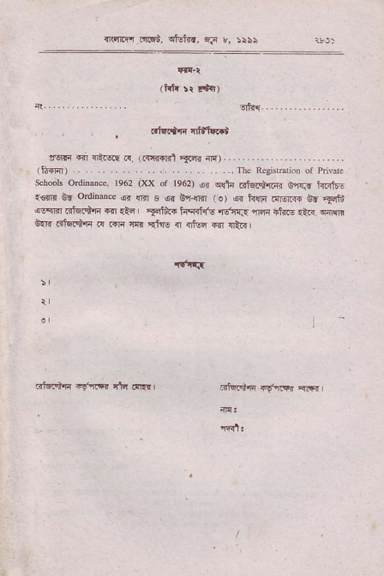
_{{rolrt olEi,} ^{qlEtr.,} fla ,, 5\5i
!w d.FN!E _{F,} ^{.{.q{Rr !Acr.} _{dJ.} ...
(lj-{En) .. .. .. .. . ...rrtc R.ejttr'ion _{or} ^{pdv} . scb@k ordinue, 1e62 ^{(xx or te62)} _{!r} ^{q!t{} Glqtdrrrrn 6'fi1[ tr.{t6- _{{€rlr Bn} ordirmc ^{qr} {Br _{3 ar bi{Er} ^{(o)} {. ^{frlB dtu]ffi 6.} *f". {9M ^{EE +E rrl} _{{l?} ' _{Fr":.. iiq{t ro} ^{qs.iR} irsr 1fr.8 _{.i...} q{$i &R .if{F a rc.ni r{r {ft$ { _{{isa *1} ql&l
Rfutnr{ i{iF nlt drE{l
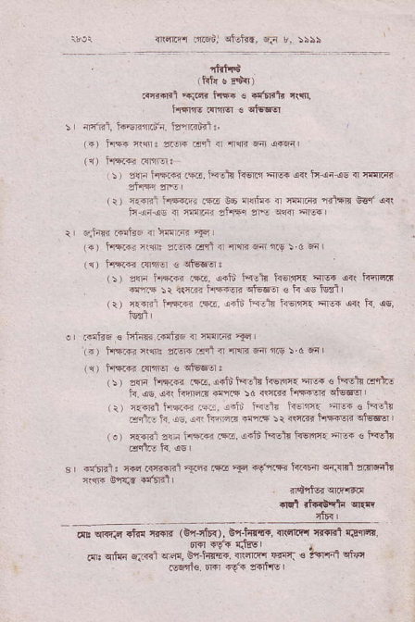
_{{.i@ tn@dl} ^{qdr.,} Fn r, :i\5
. 'ttrl'41
tfrtu s E€.r)
fr.{cl riR lift € .t'raL r$1
t$lE frreJ ! ot€.Fr
-fRl ts€iim6i. 13nRdt
⁽⁴⁾ hF n'r: :'F ral _{{r $s n} q@
_{:) ffi} ^{jrffi} _{R.. i"'etl ts6[,I} 3l@ _{a<( it!tus {} ,nd@
(r) _{{.n1ir@i4 .E B6} ^{ln$i{+} { nF(F. fitFR W art fi-!i.!s _{a} ^{JIma} drar eN i@ rc
^{srinli rEF { rF:ar} nq
(ir l"qrnr _{r$r :Jr Frl a} ^{,msnnrs} 5 a 4,
(1) i{ft.r .nfcr € ql'6@:
⁽⁵⁾ ,!d 1'{n _{i@, s+ii} ^{jn-tu} _{k65r3l} ,l@ d{l h6clt {nr.s :r {{ir. h*'@ c't66.r € h dc td I
^{(r)} ffii h'Fr _{Ri, liJt i{.tu l{ofi.} ^{qrF qn} h, oE,
.+ris€tihTrFrrr."q,nF@.*1
^{(s)} _{hFm} ^{jt@} ffi .$l { {1r< fl nry :.6 -{
(1) h!@ dN € clE@:
( | ₎ zs 1'Fffi r$b. _{!.li ffi hErF{} ^{'l@} < i-rElt d"125 ir 6s o<( hrl@ _{dff :d i\rc h4€R} qto@
^{(r)} _{{.FRl hF,q.5tr.} i-Ji i4nt _{i<Ertt} ^{'ire{} e tistu _{Efi- ti.} !q i4' lTdd.r {6:r 4@ FF€qr ekr (.r n {rq: z{. i'F@ rqE. _{{rln Wtt hsaFr} FrF : tsft]{
rr'n _{t : {rrr R{rq<l} ^{'Fft} _{ffi} ^{'F} _{Fgrl.{F hr'@} ^{qr{.sEr} 4nF1t _{rw} ^{grf.d} +t'fir11
.rd _{fnirt{} qla
rltq L
_{ar} ^{qRro} ltrr _{f<+n} (E {td), Bn_tste, {eftq'I T{rRl rdqFfr, *,.rln. .,-.1.{*. #.H ffi, *"n. !no.r oi* .!6!ns. m €6{ t{fts

